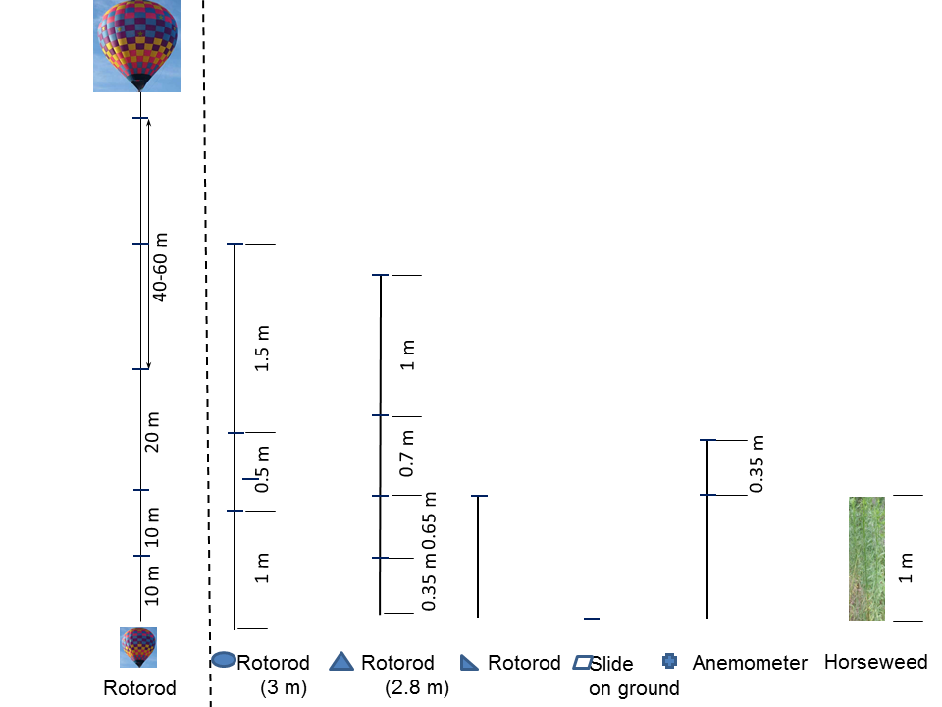

**Fig 1**: Schematic map and setup of the experiment. The wind rose: left-top, experimental site: left-bottom, sampler heights: right. In each experimental period, only the samplers (slide and Rotorod) along the downwind sampling line (either northeast or southwest direction) were used. Balloon horizontal location and sampler heights on the balloons were adjusted during experiments based on if the seed was detectable at the corresponding sampling heights and location.

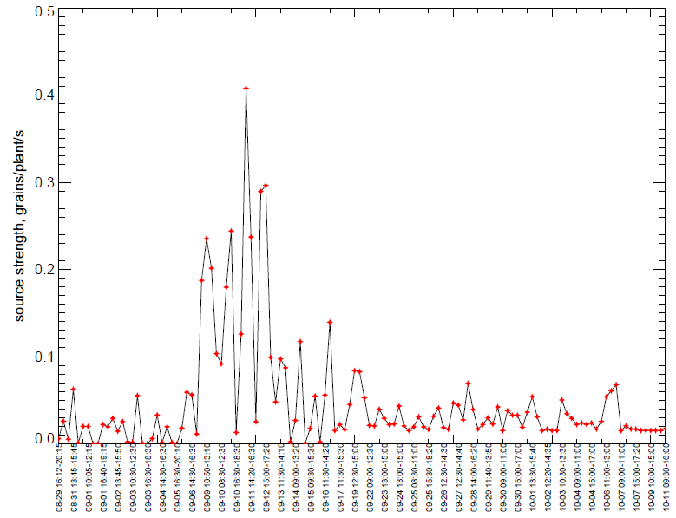

**Fig 2**. Seed source strength in experiment.

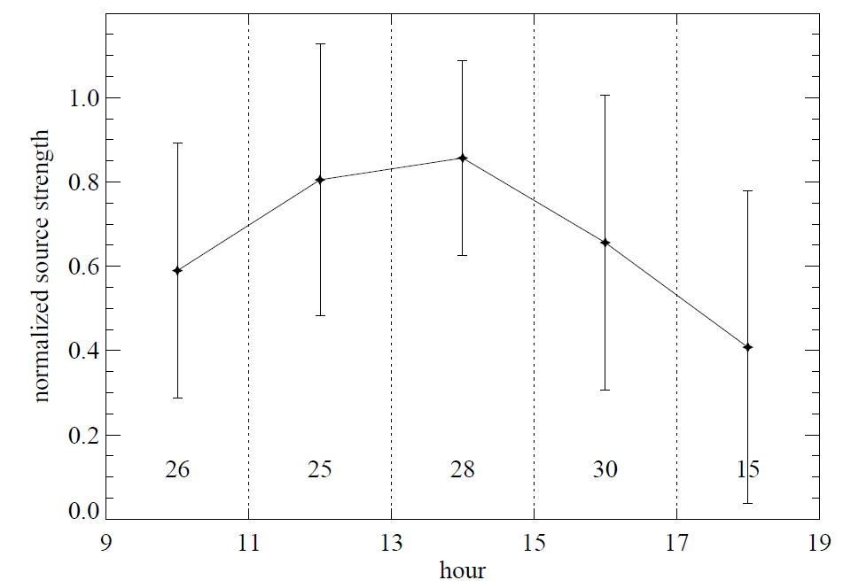

**Fig 3**. Diurnal variation of normalized seed source strength (normalized by daily maximum; the diamonds are means and bars are standard deviations). Numbers above the X axis are the number of samples used for the corresponding calculations of mean and standard deviation.

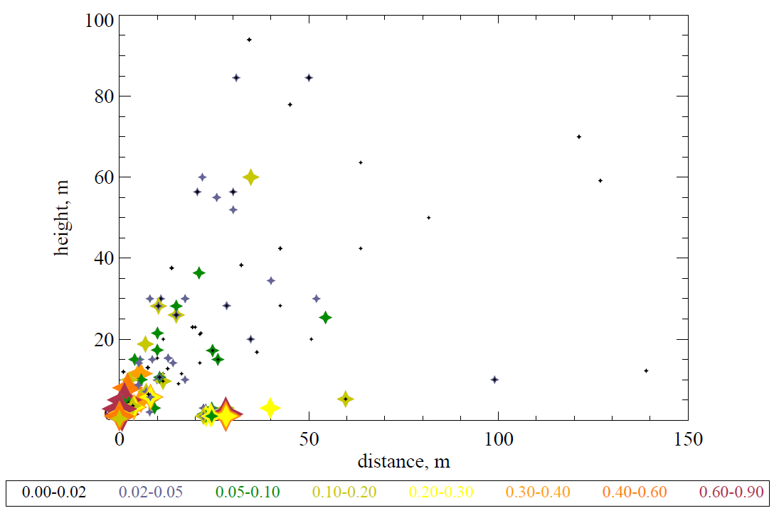

**Fig 4**. Seed concentration (seeds/m3) vs. downwind distance and height. The points at distance =0 m at different heights are the averages of the data measured at the corresponding height at distance =0 m during the whole season (showing the averages because the data were too crowded); other data are the data measured during each experimental period.



**Fig 5**. Vertical distribution of normalized seed concentration (normalized by the concentration at 0.35 m height in the source center; the diamonds are means and bars are standard deviations).



**Fig 6**. Normalized seed deposition along the downwind direction (seed deposition was normalized by the source strength; the diamonds are means and bars are standard deviations; red line is the fitted trend line).